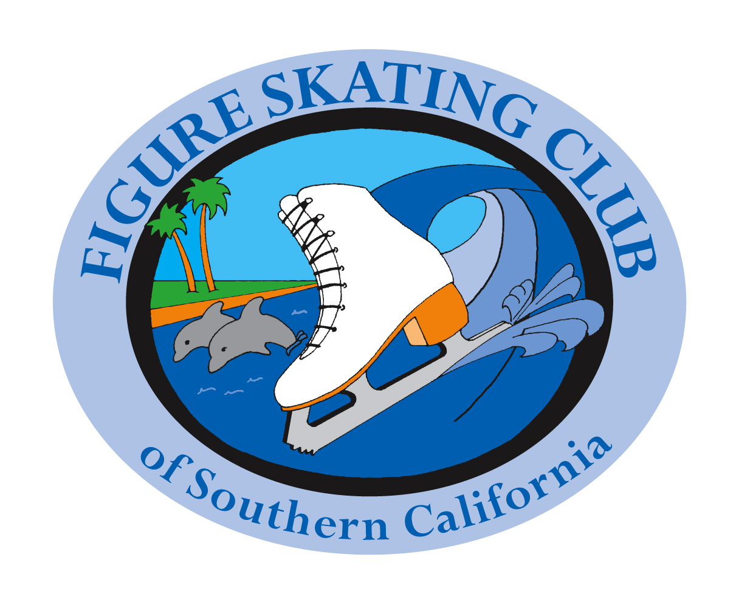
IJS Protocol for Test Credit Request Form
Effective 11/1/17

Athlete’s Name:
Athlete’s USFS member #:
Parent name, if under 18:
E-mail contact:
Phone contact:
Coach’s Name:
Coach’s E-mail:
Coach’s Phone:
I verify that the athlete listed above is eligible to receive Test Credit through IJS protocol. I have seen the unaltered and correct scores, which match the protocol the athlete is submitting. I understand that altering a protocol sheet to meet the test requirement is considered an ethics violation of U.S. Figure Skating and The Professional Skaters Association.
Coach’s signature:
Name of competition:
Date of competition:
Please attach to this form:
- The overall event results, which include the names and signatures of the Event Referee and Technical Controller.
- Your individual protocol.
- Your Test Credit Skater report from the competition.
- Processing Fee (prices are Per test & Per Skater).
- Allow at least 2 weeks for results to be recorded if mailing the form.
- Indicate below which test you are applying for:
SINGLES FREE SKATE TESTS |  | PAIRS TESTS |  | DANCE TESTS
Juvenile ($ 15) |  | Juvenile ($ 15) |  | Juvenile ($ 15)
Intermediate ($15) |  | Intermediate ($15) |  | Intermediate ($15)
Novice ($15) |  | Novice ($15) |  | Novice ($15)
Junior ($15) |  | Junior ($15) |  | Junior ($15)
Senior ($15) |  | Senior ($15) |  | Senior ($15)
Adult Gold ($15)

You may leave all forms and payment in the Club Box at Toyota Sports Center
or Mail to:
Forms missing any paperwork or signatures will be returned unprocessed. Payment will be kept as a handling fee.
When forms are re-submitted they will require another processing fee to be submitted with them.
NO REFUNDS OR CHANGES
Ann Jensen
Test Chair, FSCSC
6853 Encino Ave.
Van Nuys, Ca 91406
annmjensen@aol.com
310.849.9550 (cell/text)

